Dr. Martin Luther King Jr. Virtual Tentative Schedule
Monday, January 18, 2021 - 11:00 –AM-12:30 PM
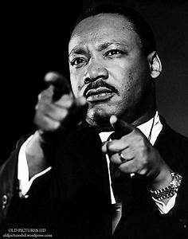
Theme: “WORKING THE DREAM”

Mistress of Ceremony: Ms. Vickie Ellis
10:55 Music/Videos of Dr. King
11:00 Opening and Welcome Pastor Douglas P. Jones
11:03 Rahim Foryoh VIDEO
11:06 Opening Prayer Bishop Theresa Lee - New Birth International
11:10 Senator Gary Peters
11:15 Margaret Dimond-CEO McLaren Regional
11:20 Congresswoman Brenda Lawrence
11:25 Mayor Deirdre Waterman
11:30 - Selection Sean Preston, Opportunity
11:40 State Rep Brenda Carter
11:45 Commissioner Angela Powell
11:50 Superintendent Kelley Williams
11:55 Quest All Stars Cheer Team-VIDEO
12:05 Ahmad Taylor
12:12 Lisa Washington
12:15- Selection Sean Ginyard
12:20 Senator Rosemary Bayer
12:25 Pastor Douglas P. Jones

DPJ/dns

